people and land:

greenspace and related issues

User Guide

White Bar Art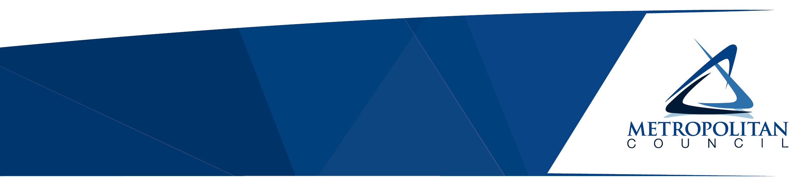

The Council’s mission is to foster  
efficient and economic growth for   
a prosperous metropolitan region

**Metropolitan Council Members**

|  |  |
| --- | --- |
| Charlie Zelle Chair Judy Johnson District 1 Reva Chamblis District 2 Christopher Ferguson District 3 Deb Barber District 4 Molly Cummings District 5 Lynnea Atlas-Ingebretson District 6 Robert Lilligren District 7 Abdirahman Muse District 8 | Raymond Zeran District 9 Peter Lindstrom District 10 Susan Vento District 11 Francisco J. Gonzalez District 12 Chai Lee District 13 Kris Fredson District 14 Phillip Sterner District 15 Wendy Wulff District 16 |

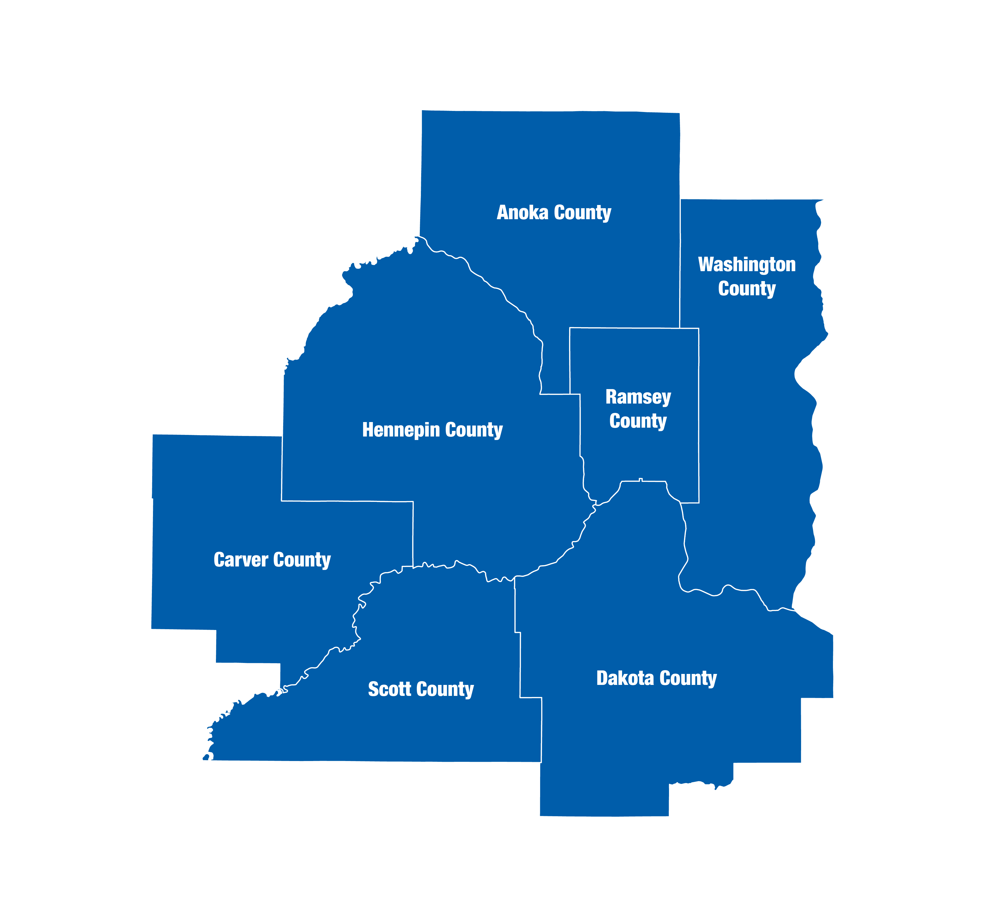  
The Metropolitan Council is the regional planning organization   
for the seven-county Twin Cities area. The Council operates the regional bus and rail system, collects and treats wastewater, coordinates regional water resources, plans and helps fund regional parks, and administers federal funds that provide housing opportunities for low- and moderate-income individuals and families. The 17-member Council board is appointed by and serves at the pleasure of the governor.

On request, this publication will be made available in alternative formats to people with disabilities. Call Metropolitan Council information at 651-602-1140 or TTY 651-291-0904.

# About this report

Thrive MSP 2040 charges the Council to advance stewardship, prosperity, equity, livability, and sustainability within the Twin Cities region.

Some progress has been made in each of these areas, yet there remain and interconnected issues that demand further consideration. One of these is the relationship people have with their environment. Natural environment, greenspace. It influences health and livability of a region, the benefit distribution is heavily inequitable. Much information exists, and yet there is no comprehensive synthesis for the Twin Cities Region in a way that gives this information power for change.

Other words, better words

This study synthesizes the relationship between people and the natural environment in the Twin Cities region. It covers the history of this relationship, how climate change has impacted it, and a plan for the future.

Redling

Extreme heat

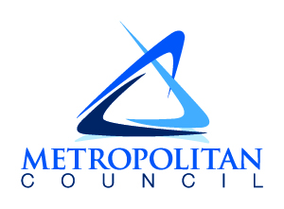­390 Robert Street North  
Saint Paul, MN 55101-1805

651.602.1000  
TTY 651.291.0904  
[public.info@metc.state.mn.us](mailto:public.info@metc.state.mn.us)  
metrocouncil.org

Follow us on:  
twitter.com/metcouncilnews  
facebook.com/MetropolitanCouncil  
youtube.com/MetropolitanCouncil

